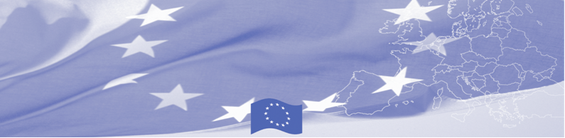

**PRESS RELEASE**

**Media trainers from Central Asia improve skills**

**for reporting on conflict-sensitive topics**

**Bishkek, 20 January 2020**

Two ten-days Training for Trainers (ToT) on conflict-sensitive journalism and conflict-sensitive digital (online) communication were launched today on January 20, 2020, with participation of professional media trainers from Central Asian.

ToT started with a welcoming speech by Charlotte Adriaen, Head of Cooperation Section, the Delegation of the European Union to the Kyrgyz Republic.

Ms. Adrien noted: “*Quality journalism for preventing violent extremism is very important. You are in fact one of the main carriers of information. Having quality information, resilient journalists and journalism is key for preventing violent extremism. The EU adopted new EU Central Asian Strategy last year and we continue looking at security issues to contribute to peace and stability in this very important region. You will be part of this work because we also work with the media. We have delegations in all countries of the region, and we are there not only to represent the EU and to implement projects but also for you. We are open to meet and discuss your concerns and support needed because it is also our responsibility*”

ToT graduates will attend a comprehensive training program, which includes training for trainers, mutual mentoring trips and sub-grant support for participation in thematic regional and international events to enhance knowledge on violent extremism issues, preventing violent extremism (PVE) concepts and practices.

The main goal of the ToT is to train 30 media professionals (6 per country) to expand the pool of media trainers capable of conducting trainings on conflict-sensitive journalism in the regions of target countries, and strengthening communication capacity of state press-service officers and religious/community leaders.

In collaboration with international experts in the field of PVE and conflict-sensitive reporting, Internews developed two ToT modules:

**Module 1** will help participants design and conduct future workshops for media representatives, content producers, and civic activists. The curriculum is based on ToT developed for the first phase project named “Contributing to stability and peace in Central Asia” by Peter Du Toit, a renowned international expert on conflict-sensitive reporting. Mr. Du Toit adapted the course including the lessons learned of the first phase and the needs of the additional target group (civic activists), and will also lead the updated course.

**Module 2** is focused on conducting trainings for press officers and religious / community leaders.Internews together with the PVE experts from Albany Associates developed a training program based on the results of the first phase. Albany Associates brings together experts in the field of strategy and

solutions, media development, training and research, outreach and advocacy for ensuring peace and stability, and strengthen community resilience to radicalisation leading to violence.

Based on modules developed and adapted to local conditions and training tasks, ToT graduates in their countries will conduct series of trainings for their target audiences (journalists / bloggers and civic activists, press service officers, religious and community leaders) and provide mentoring support to the winners of a sub-grant competition for content production starting from the production stage till the final product is received. Each seminar includes practical work for one month in order to ensure the practical application of the acquired skills.

Training of trainers will be organised within the framework of the project **“Strengthening Resilience to Radicalization and Disinformation in Central Asia”, funded by the European Union and implemented by Internews**.

**The main goal of the project is to strengthen citizens' resilience to radicalization and misinformation leading to violent extremism by supporting the media, civil society, government institutions, religious leaders and active citizens in Central Asia.**

The ToT will be held at the Park Hotel in Bishkek, Kyrgyzstan from January 20 to 31, 2020.

For additional information, please contact the project team by email [central-asia-info@internews.eu](mailto:central-asia-info@internews.eu).



|  |  |  |
| --- | --- | --- |
| A project is implemented by:  Internews  Address: 115 Ibraimov St., business centre “Asyl-Tash”, 11th floor, Bishkek, 720021  Kyrgyz Republic  Tel: +996 312 986880  Email: [Central-Asia-Info@internews.eu](mailto:Central-Asia-Info@internews.eu) | This project is funded  by the European Union  Delegation of the European Union to the Kyrgyz Republic 21 Erkindik Boulevard, Business Centre Orion, 5th floor Bishkek, 720040, Kyrgyz Republic  Telephone: +996 312 26 10 00 Fax: +996 312 26 10 07  E-mail: [delegation-kyrgyzstan@eeas.europa.eu](mailto:delegation-kyrgyzstan@eeas.europa.eu)  Website: <http://eeas.europa.eu/delegations/kyrgyzstan>  Facebook: <http://www.facebook.com/eudelkg> | The European Union is made up of 28 Member States who have decided to gradually link together their know-how, resources and destinies. Together, during a period of enlargement of 60 years, they have built a zone of stability, democracy and sustainable development whilst maintaining cultural diversity, tolerance and individual freedoms. The European Union is committed to sharing its achievements and its values with countries and peoples beyond its borders. |